

Training Guide

For Trainers and new hires

Ellie Day

# Table of Contents

Table of Contents 1

Day 1 2

Labels, Load Techniques 2

Scanners 3

Day 2 5

Day 3 7

Saturday/Monday 8

Splitting 9

Unload 10

Primary 10

IC’s 10

Other 12

Stickers to look for 12

Old Scanners 14

Damaged vs. Not Damaged 16

How to tape a package 16

Examples of Damaged Packages 17

Examples of Repacks 18

Non-Damaged Packages 18

# Day 1

## Labels, Load Techniques

Every package at FedEx should have an Address Label and a Vision Label. A Vision Label will tell the Package Handler (PH) where the package needs to go, and where on a truck to load it. There are two main things to look at:

424-5063

ETP: 2

The first digit, 4, tells us the van line. The next two digits, 24, tell us the truck (Work Area). The next digit, 5, tells us the shelf, and the last 3 digits, 063, tell us where on the shelf the package should be loaded.

ETP stands for “estimated total packages.” Essentially, it is how many packages are also going to that same address. Occasionally this number is incorrect, but it is nothing to worry about most of the time.

The Address Label is the label you will need to scan before or while you load the package. Scanning the Address Label will update the driver’s delivery manifest so that the delivery can be made on time without error. Failing to scan the Address Label reflects on you, and the driver may not know the unscanned package is on their van. It is important that every package be scanned and loaded properly.

Proper load technique is simple. It should be demonstrated by the trainer, but here is a quick description. The Address Label can face one of three directions when the package is loaded properly on the shelf: Upwards - towards the ceiling, Forwards - towards the other shelf, or Facing the Driver - regardless of the side of the truck the package is loaded. The Vision Label should be moved from wherever it is to the side of the box most visible from the aisle, parallel to the floor and not upside down.

IC’s are packages that are too heavy, too large, or too dangerous (hazardous materials) to send up the belt like normal packages. They are almost always loaded on the floor of the truck.

Smalls are packages that are too small and light to send up the belt like normal packages. They come to the van line in totes, and are unloaded from the tote, usually more than one small at a time, so smalls usually travel down the belt in groups. When loading smalls, they should be placed on top of packages instead of directly on the shelf when applicable.

Empty smalls totes are sent up the belt at the end of the day, usually of a different color, to signal that the unload is finished with smalls and regular packages. This sometimes means that you are completely done with the sort, and all that is left is to clean your Work Area and deposit your scanner.

## Scanners

Knowing how to set up a scanner is essential to being able to perform the job. We currently use two types of scanners, which will be called Old and New. Van Line PH’s will almost never use old scanners. Setting up a new scanner is very easy and does not take long. Grab a wristband - white button for small or black button for large, a scanner, a trigger, and have your FedEx employee badge handy.

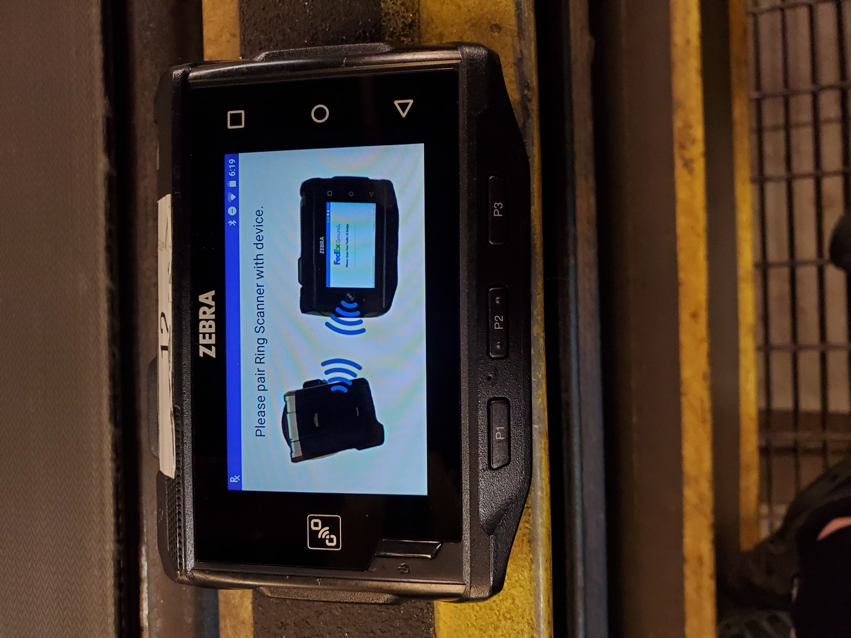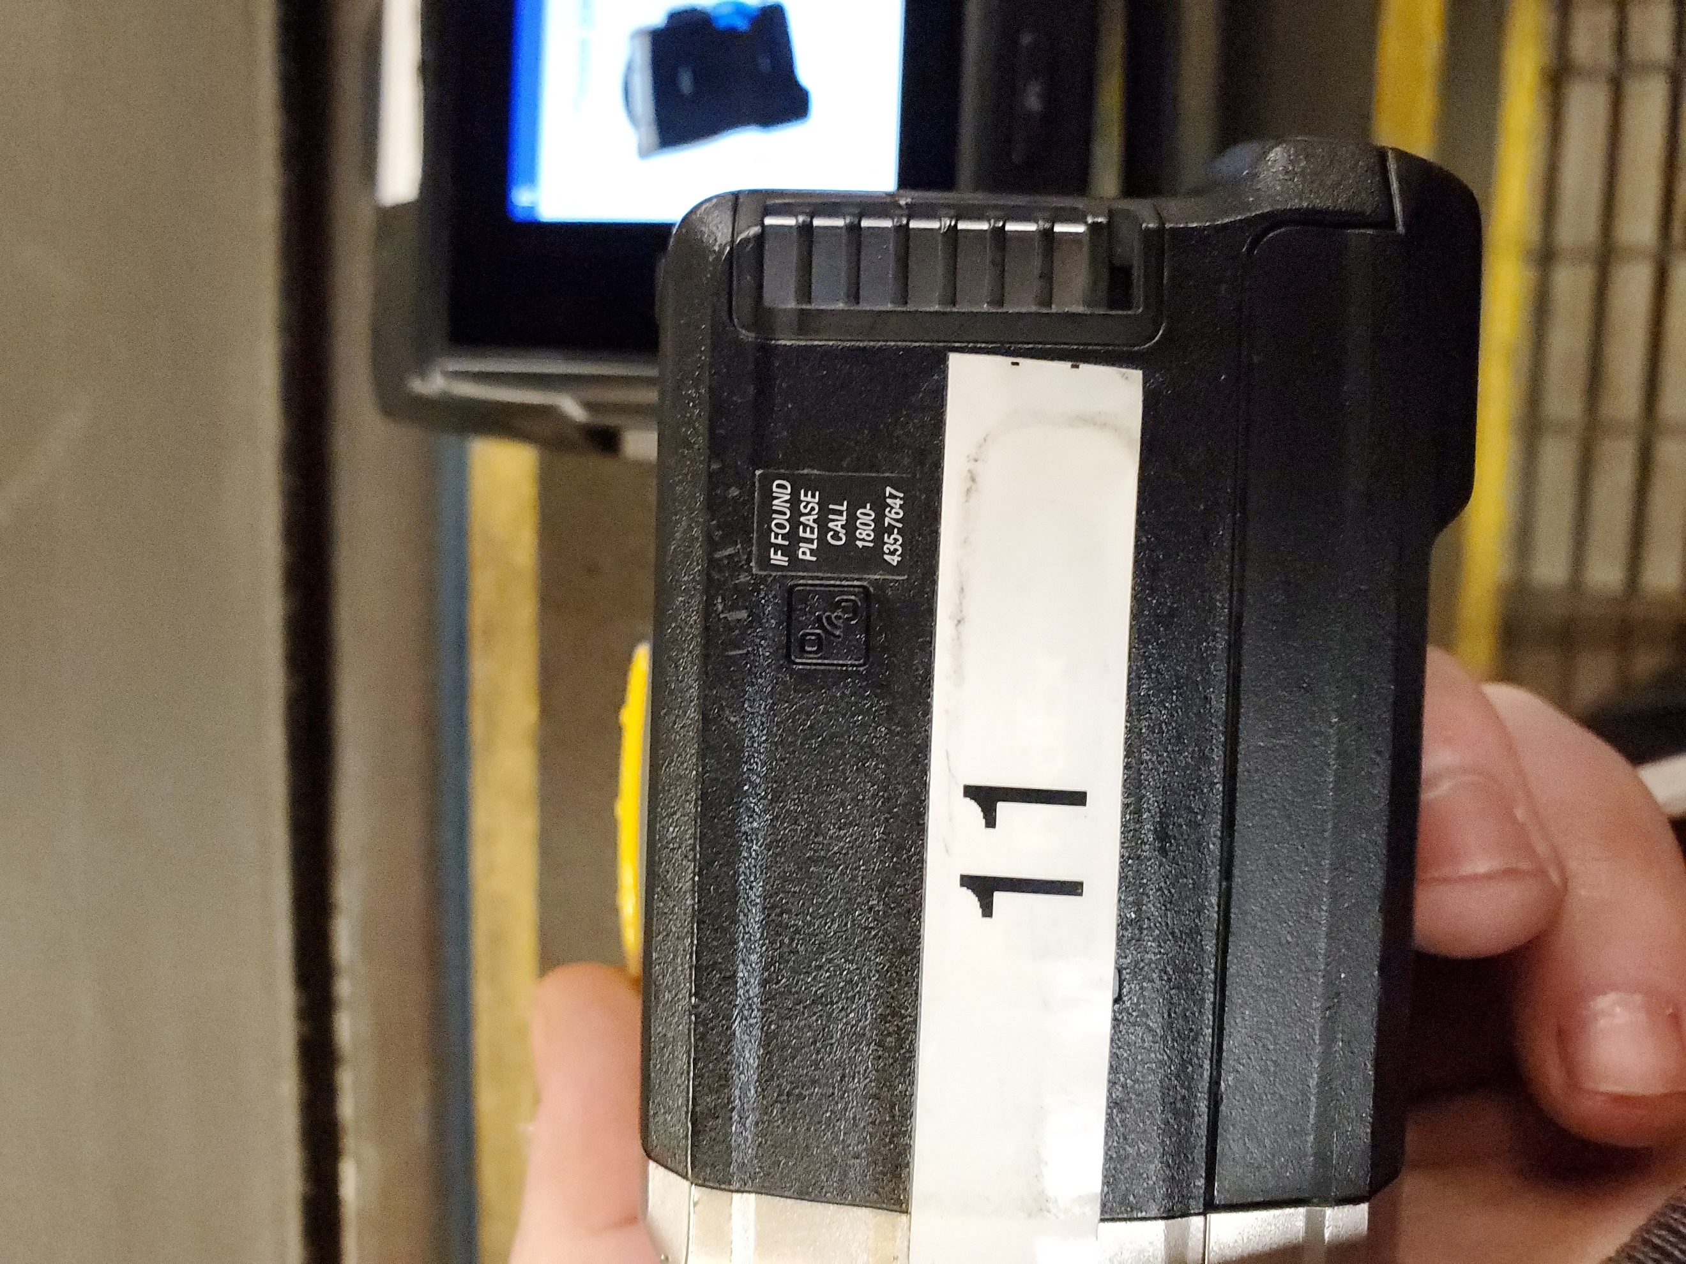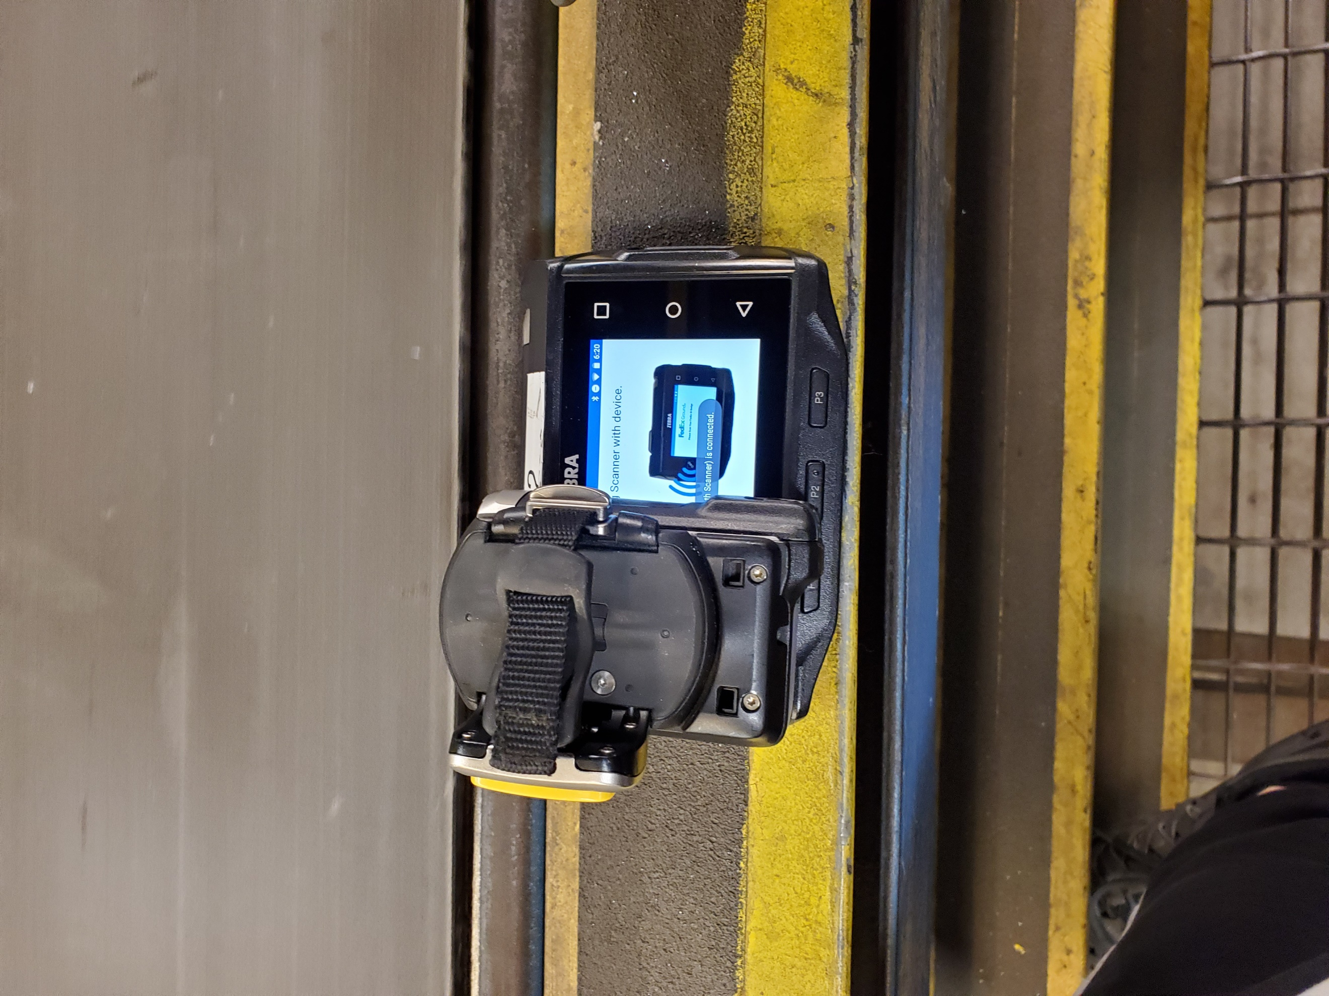

Find the logo on the trigger, hold it over the same logo on the scanner to pair. After the two are paired, slide the scanner onto the wristband and put the wristband on. Pull on the button to pop it out (should spin clockwise without any resistance). Pull on the back of the wristband to open it up. When satisfied, push the button to pop it in, then rotate the button clockwise to tighten the wristband.

The trigger will rest on your index and middle finger. It rotates around the yellow button so it can be used on the left or right hand. The light and laser should shine away from you when wearing the trigger, the yellow button between your index finger and thumb (push the button with your thumb). On the opposite side of the button is a gray tab, lift it up and then you should be able to pull the strap to tighten. Push the tab back down to prevent the strap from loosening.

Scan your badge. Day 1 New Hires may need to use their trainer’s badge because of technical reasons which prevents them from finishing this process. After the badge is scanned, you should hit the button in the middle to go to applications. If the touchscreen does not respond, press the P3 button to unlock it. Open the Work Area Scan app.

Now you should be ready to set up your trucks and start loading. Hit the Add button to add a Work Area. Scan the work area tag (the orange/yellow tag on the belt) or enter the Work Area number manually, then scan the vehicle tag (on one of the shelves usually) or enter the vehicle number manually (found on the outside, on the back of the van, usually in one of the upper corners). Repeat for the number of trucks you are loading or scanning. When finished, hit Continue.

FedEx recommends all its Package Handlers use the Scan to Scan technique when scanning and loading packages to vans and trucks. The Scan to Scan technique is where instead of first scanning your package and then tapping on the screen the van your package is supposed to be loaded onto, you scan your package, load your package, and then either scan another package on your way out of the van or scan the orange vehicle tag on the belt. The Scan to Scan technique is intended to reduce the chances of misloading a package onto the wrong van.

Sometimes drivers will request that you place one of their packages on another vehicle. This is an easy task that requires you to scan a package to the WRONG Work Area intentionally. This will not count against you; however, it is possible to do this by accident. Accidentally loading and scanning a package to the wrong Work Area is called Misloading, and it is counted against you.

Place packages moved by drivers under the belt in front of the truck it will be loaded on or place them in or near the cab of the truck - do not load the package by its Vision Label.

Finally, old and new scanners have a scan mode called Bulk Scan. Instead of scanning a package you intend to load, and then another package on the truck, Bulk Scan requires one scan to load. Hit the Bulk Scan button, select the Work Area to which you are scanning, and then scan the correct Address Label barcode. If done correctly, it will have the same effect as Scan to Scan and is only useful if you are loading multiple packages to the same van at the same time.

Trainers:

* If the trainee’s spot is currently slow, and they are caught up, let them pull their own packages from the belt.
* If the trainee’s spot is currently fast, stack packages on the back of the van for them. Make it easy to grab and load quickly. Make sure the packages are scanned.

Before the end of day, catch them up and let them get used to pulling packages from the belt and loading them (without stacking, if can be helped)

# Day 2

Day 2 is the day trainees should use to really familiarize themselves with the belt and get up to speed to not “stack out.”

When you are looking on the belt for your packages, it is important to remember to charge the belt, and constantly move forward to look at every package coming past you. One of my personal methods of charging the belt is something I call the 15 Second Rule. On the side of the belt is a metal rail that is welded to the belt, with the E-Stop cable running on top of it. You will use the weld spots to measure how long you have before a package comes to you.

15 Seconds is roughly equal to three and a half weld spots, so the 15 Second Rule is when you go to your first truck, and you look 15 seconds, or three and a half weld spots, up the belt and look for your packages. Typically, you don’t want to move or look further than 15 seconds, but there are exceptions. Package Handlers should look 15 seconds ahead before loading any packages that are stacked on the ground and not loaded. The belt is the #1 priority, not the stacked packages. Load all packages on the belt until you have a 15 second window or more with no packages for any of your trucks, and then move on to loading your stacked packages. You should not be sitting still unless you have an empty 15 second window and you have no stacked packages on the floor. If you have extra time you should be helping the loaders around you.

If you must stack your packages on the ground because you cannot load them quickly enough, stack them properly. Place packages on the back of the van, either on the driver or passenger side, with room between so you can still enter and exit, with the largest or heaviest on bottom and smallest/lightest on top. If necessary, push your stack forward and then start a new stack behind it. Try not to stack outside the truck so you save time when catching up - stacking outside means you need to travel further for each package you intend to load.

IC’s are loaded differently to normal packages. My personal method of loading IC’s is as follows:

Hold 1000’s, 2000’s, and 3000’s outside the van

Wait for an IC in the 8500, 8000, 7500, 7000, or 6500 section to come down, load it flat on the floor or flush against the wall. If your first package is in the 8500 section, your next package will be a lower section, such as 8000 or 7500. You are not to load a smaller number behind or below a larger number (4000 behind or below an 8000 for example), because the smaller number should be delivered before the higher number. Therefore, IC’s are loaded in the order they come out.

If a lot of IC’s are currently held outside the van, skip the high numbers and instead start with your current highest number and load them when you have free time. Reorganizing your truck might be necessary. Reserve a spot in the truck for the high numbers if they do come down later.

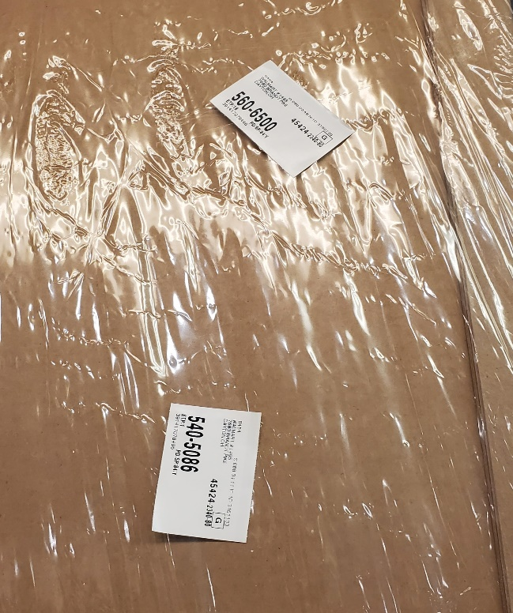Sometimes a package will come down the belt with more than one Vision Label on it. When you see more than one Vision Label, scan the package and read your scanner to determine where the package goes.

A package might instead come down that either doesn’t belong on the van line or another Package Handler did not see it and missed it. If this is the case, remove the package from the belt. If you know where it goes, you can take it there, or you can place it in the next PH’s Work Area so the package works its way to the front of the belt. That is especially useful if you don’t have enough time to move it very far. Likewise, check the end of your Work Area for packages you may have missed.

The “Stickers to look for” section shows and briefly describes each Vision Label you may come across and what it means. If you ever have doubts or questions about a package you should pull it off and ask someone about it. Do not let it go past you.

Trainers:

* If you haven’t already, show trainees all nearby soft stops and especially the E-Stop.
* If you haven’t already, briefly explain jams and when the unload “goes dry.”
* If you haven’t already, briefly go over the Damaged vs. Not Damaged section of this training guide.

# Day 3

By Day 3, trainees should be able to correctly scan and load packages onto more than one van/truck with minimal misloads and unscanned packages. Use this day to correct any bad habits and answer questions trainees might still have.

Trainers:

* If you haven’t already, inform trainees about opportunities for more hours
  + Prime: Available most days, come in a half hour early to help prepare the sort for the day (opportunity to work with old scanners).
  + Chewy/Speedway: The 734 Work Area is a special work area next to the 600 van-line where Speedway and Chewy packages are loaded onto separate pallets. After the sort concludes, these pallets are wrapped, and you use a pallet jack to move them to Door 24 before loading. Chewy pallets are loaded before Speedway pallets.

# Saturday/Monday

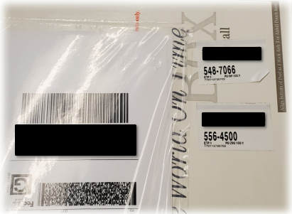On Saturday, FedEx stops delivery of Ground packages to businesses and only does Home Delivery. Ground delivery resumes on Monday.

Ground packages have a G next to the barcode in the Address Label. After they get unloaded on Saturday, they are split separately from Home Delivery (H) and Smart Post (S) and they get reloaded onto a different trailer. They do not go out.

On Monday, those trailers are unloaded. Most or all the packages from Saturday will have more than one Vision Label on them. If you are confused, scan the package and read the scanner to find where the package belongs.

All Ground packages on Saturday have generic Section ID's, such as 4500 or 8000, instead of 1089 or 6540, for example. On Monday, this is an easy way of figuring out which Vision Label is the new one, because most of the time Vision Labels do NOT have generic SID's. The generic one will be the old one.

# Splitting

The first position on the van line is the most important because it is where the packages on the belt are sorted.

Packages on the belt are sorted based on their Work Area. All EVEN Work Area numbers (524, 528, 532, 536, 540, 544, 548, 552, 556, 560, 564, 568) stay on the side of the belt closest to you.

ODD Work Areas are different for each van line. Some lines have rollers and others do not. The van lines with rollers are split, so most odd packages will go down onto the rollers, and the rest will stay on the side of the belt farther from you. For van lines without rollers, all odd packages will go on the opposite side of the belt.

*Make sure Vision Label and/or Address Label are visible.*

Sometimes a package from another van line will come to yours. Those are called Recycles. Recycles are to be held off (kept at the front) until you have the time to send them up the recycle belt, located behind the chute.

The splitter is responsible for the Smalls Totes that come down the chute. Occasionally a tote will come down the chute full of envelopes and bags that can't come down the belt on their own. When you have some free time, work to empty the totes and set them aside so the next tugger driver can grab them. For van lines with rollers, it might make more sense to leave the smalls that would go down the rollers in the tote until they are all that remain, and then send them all down at once inside the tote.

IF YOU SEE A PACKAGE THAT DOES NOT GO DOWN THE BELT PAST YOU OR DOES NOT GO TO YOUR VAN LINE AT ALL, TAKE IT OFF.

# Unload

## Primary

Primary packages are the main packages we handle at FedEx. They are not IC’s or Smalls. These vast majority of these packages will be unloaded onto a conveyor belt and travel through the building to the van lines.

First and foremost, it is important to always remain cautious, and watch your footing while in the Unload, especially if you are in and out of trailers. The majority of accidents at FedEx happen when entering/exiting a van or a trailer. The first step to getting into a trailer is to make sure there is enough room for you to enter and stand comfortably, without fear of boxes tumbling down into you should they fall over. If a pile of boxes should fall over, or looks rather unsafe, back out of harm’s way and let it fall. While unloading, it is important to never turn your back to the wall of packages. Should it fall over, you will want to see it coming.

Working from top to bottom, side of the trailer to the center, you will grab a package and place it flat on the rollers if the trailer has rollers. Make sure the Address Label is facing up or facing toward the door scanner. Some trailers don’t have rollers built-in, so depending on if you’re using rollers that were moved into the trailer or a belt that extends into the trailer, the method will be the same for placing the packages down.

If you come across IC’s, you want to pull those out of the trailer and onto the rollers next to the belt for the IC team to grab. Packages that weigh more than 75 pounds cannot travel up the belt. Packages that weigh more than 100 pounds require a team lift. If a package is tall/long, or you’re unsure about whether it’s an IC or not, there should be a red line on the wall on your left-hand side (looking out of the trailer). Bring the package up to measure – if it touches any part of the red line while flat on the ground, it is too large to travel up the belt. If a package meets neither of those criteria, but is too wide for the belt, it cannot travel up the belt. Finally, if a package is a valid hazmat package, it cannot travel up the belt.

## IC’s

IC’s are packages that are too large to travel up the belt to the van lines. Instead, FedEx uses electric vehicles called “tuggers” which tow three carts behind them to various van lines to drop off the IC’s where they are supposed to go.

The IC team is divided among the entire Unload. One part will be on Door 14, unloading the (usually) dedicated IC Trailer onto a set of rollers that extend to the tuggers which are parked close by. One or more parts will be around the Primary belts, pulling IC’s off the rollers next to the belts and loading them onto nearby tuggers. When one of these areas goes empty, the individual parts of the team float around to where IC’s are abundant and start loading, to stay productive.

When loading tugger carts, try to keep the packages on their flat side and stack them up if possible. It’s important to remember that there is a maximum height that you cannot load past – the path for the tuggers sometimes goes under the belts or under the sprinkler system and it’s important that no package is loaded in a way that it will hit these obstacles while driving past.

If you are moving a package that can’t be loaded yet onto a tugger cart, or there is no tugger to load, there are marked areas where they can be temporarily placed while waiting on a new tugger to arrive.

# Other

## 500 EVEN Vision LabelStickers to look for

This package is on one of the even side trucks, or it has a bad address. Hold off to the side and ask a driver or manager where it should go (based on Address Label)

There may also be packages with Vision Labels that read, “500-ODD.” These are essentially the same -- pull them off and ask where they go.

This package could be on any truck on the 500. Check if it has a Work Area written on it.

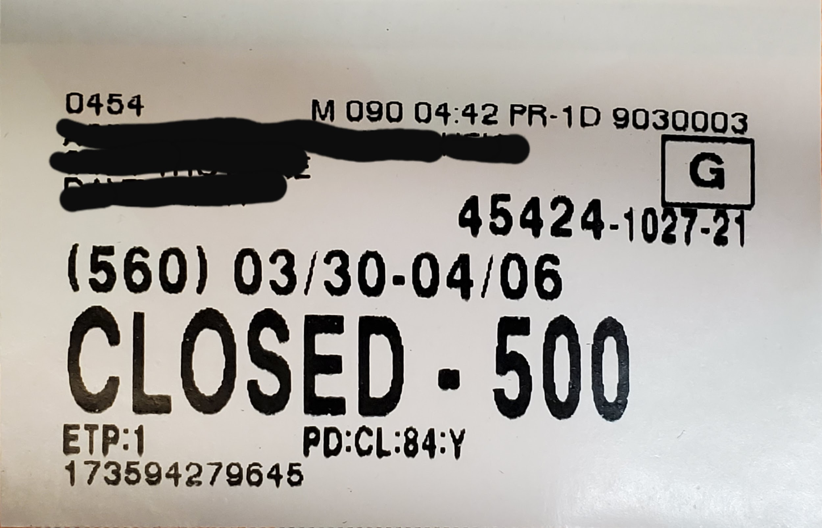

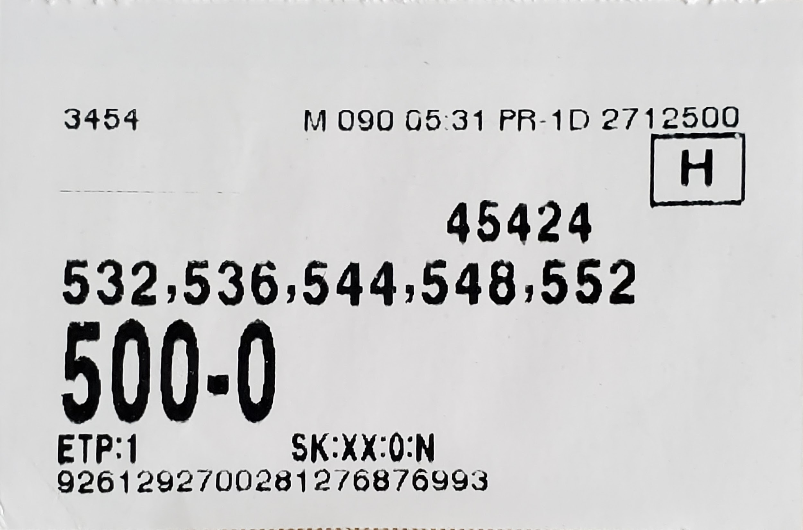

Usually on Saturdays only. This package goes to a truck on the 500 but it is not being delivered today.

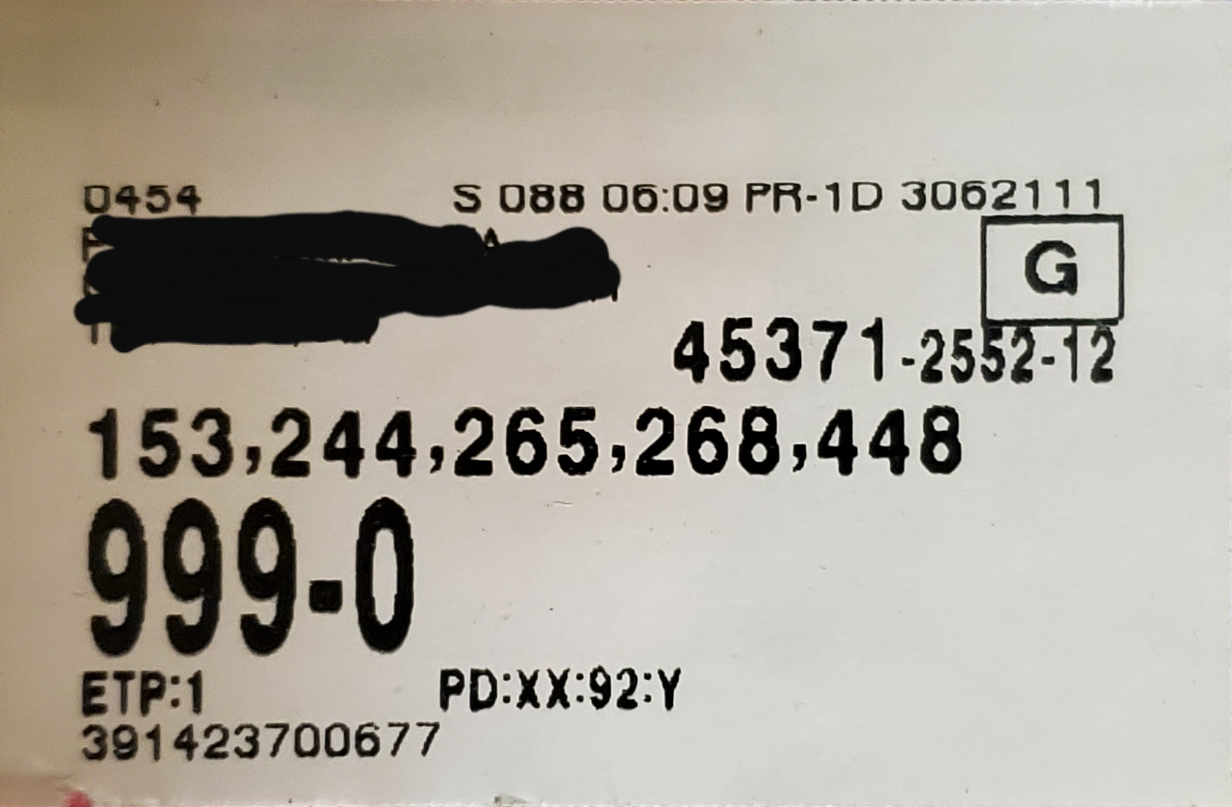

This package could go anywhere in the building. Check if it has a Work Area written on it.

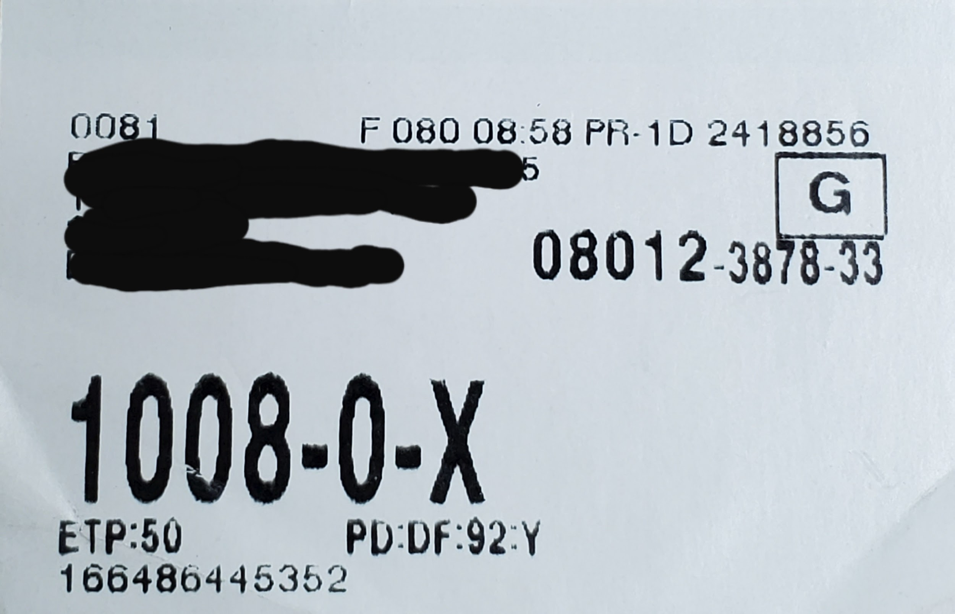

FL = Floor

AC = Address Change

This package has been dock-flexed from one Work Area to another. Dock-flexing is useful when moving more than one package.

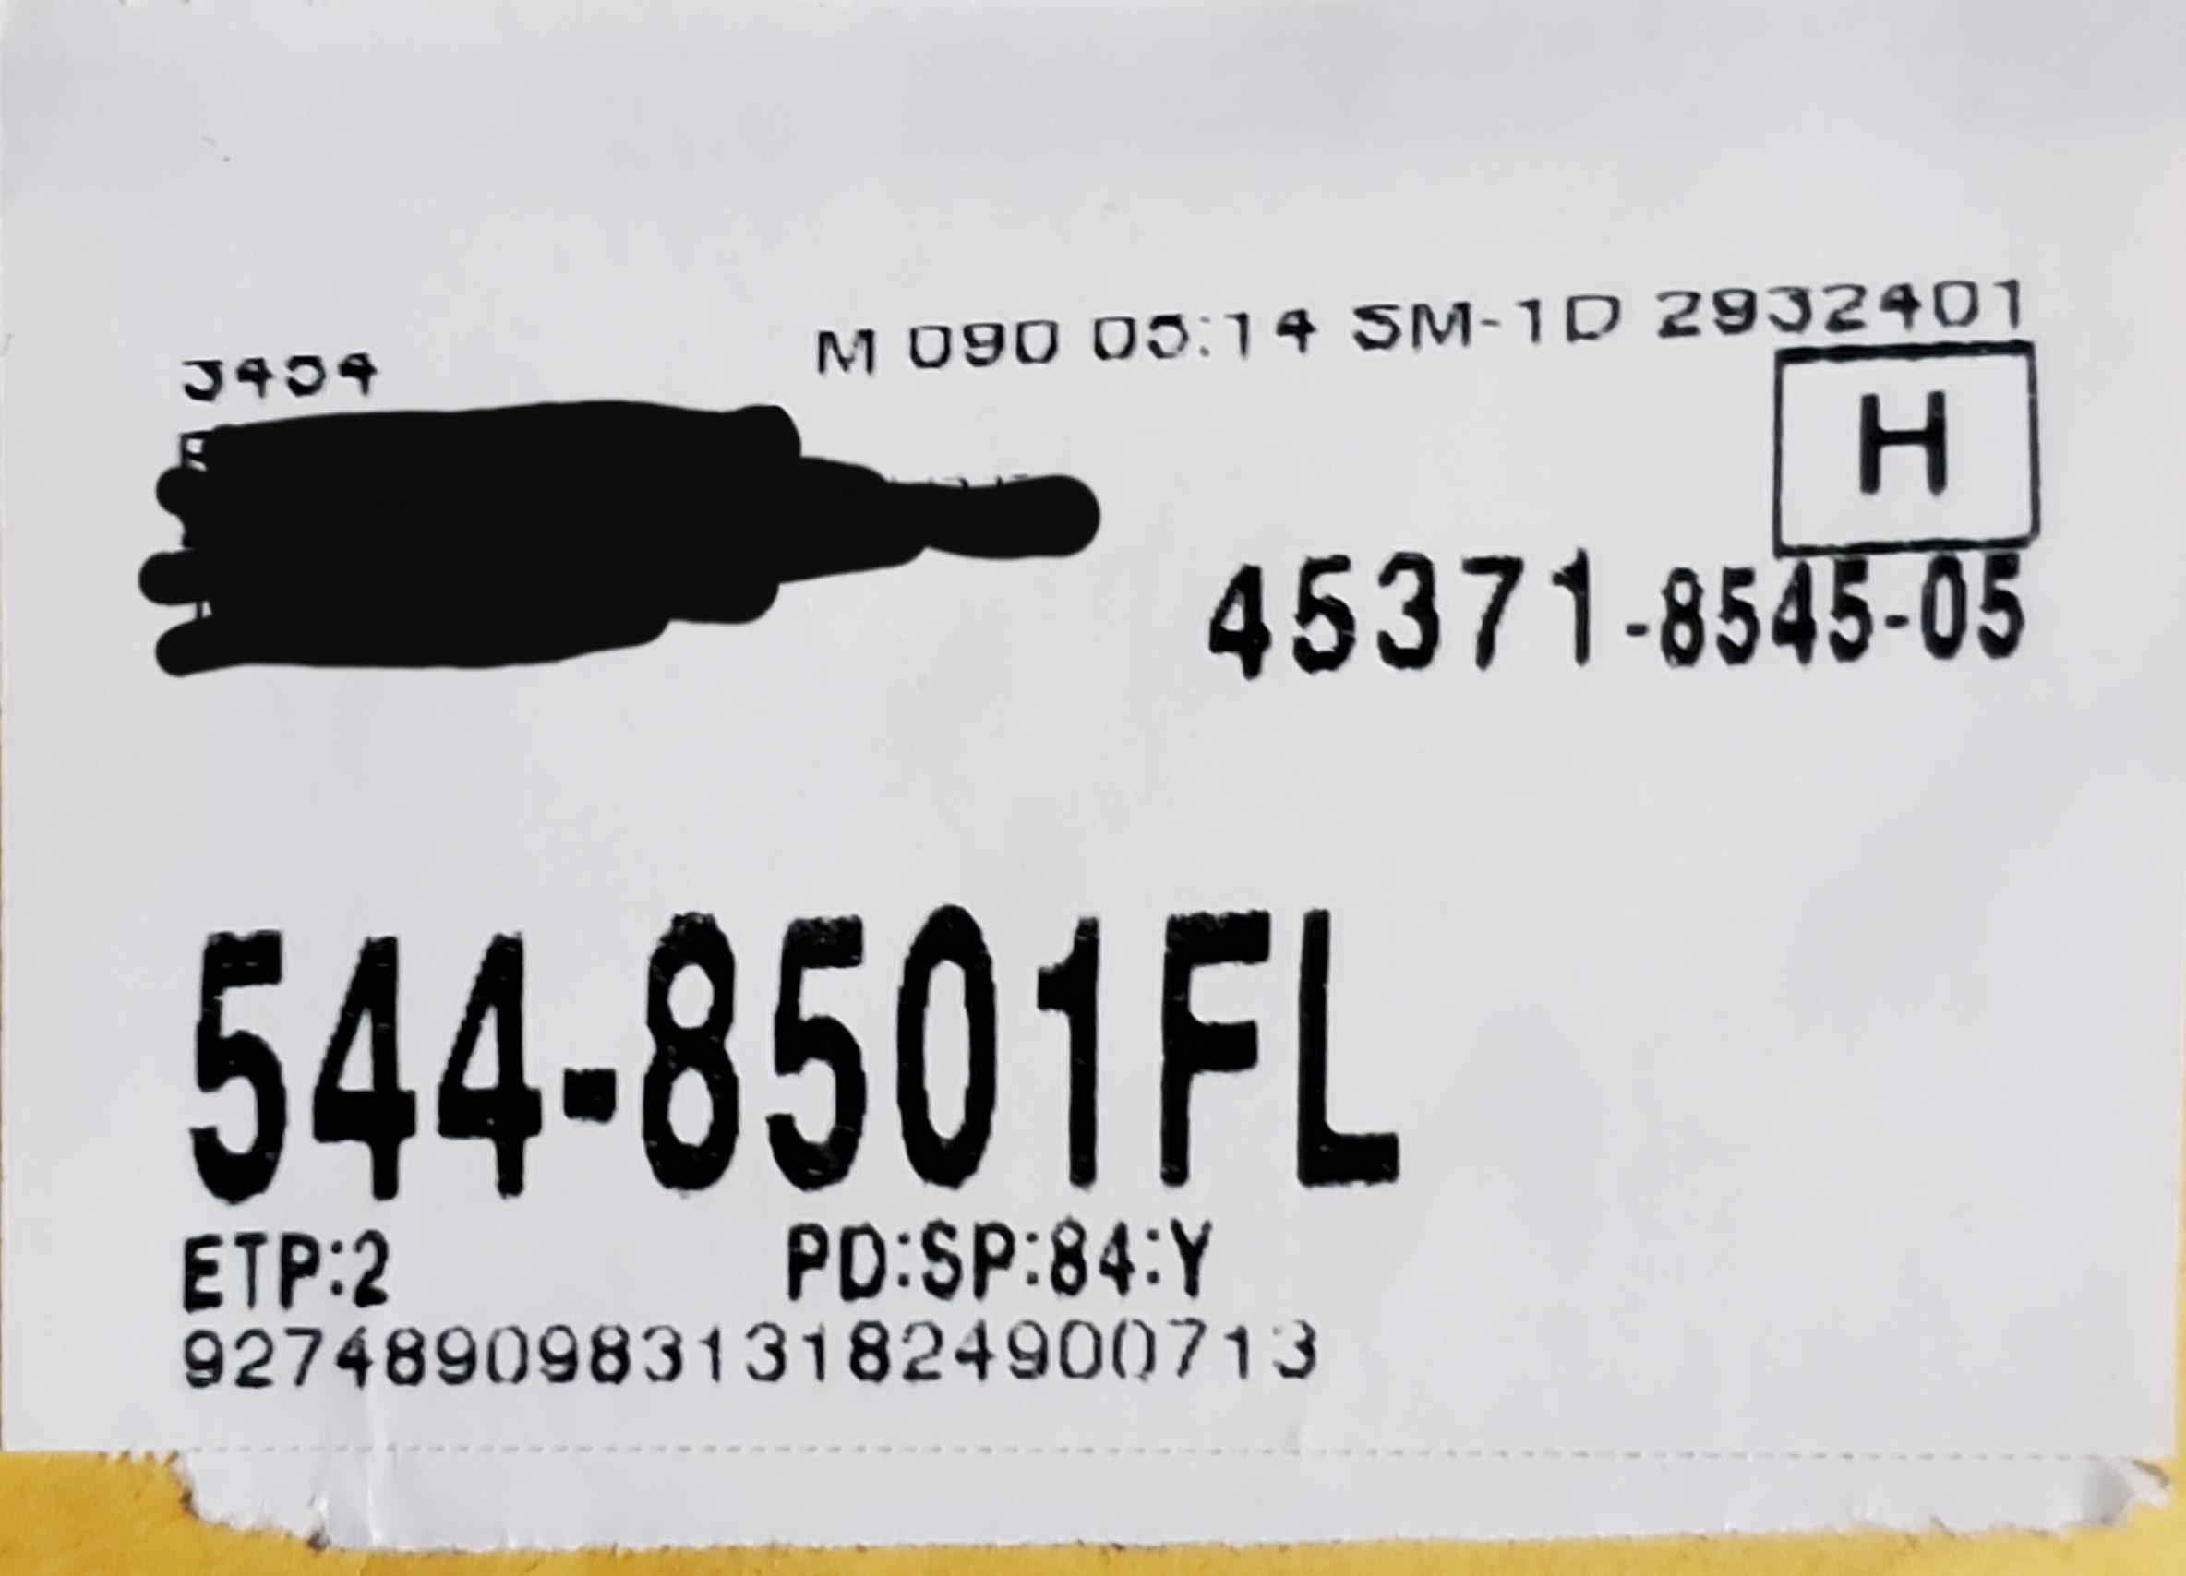

## 

## Old Scanners

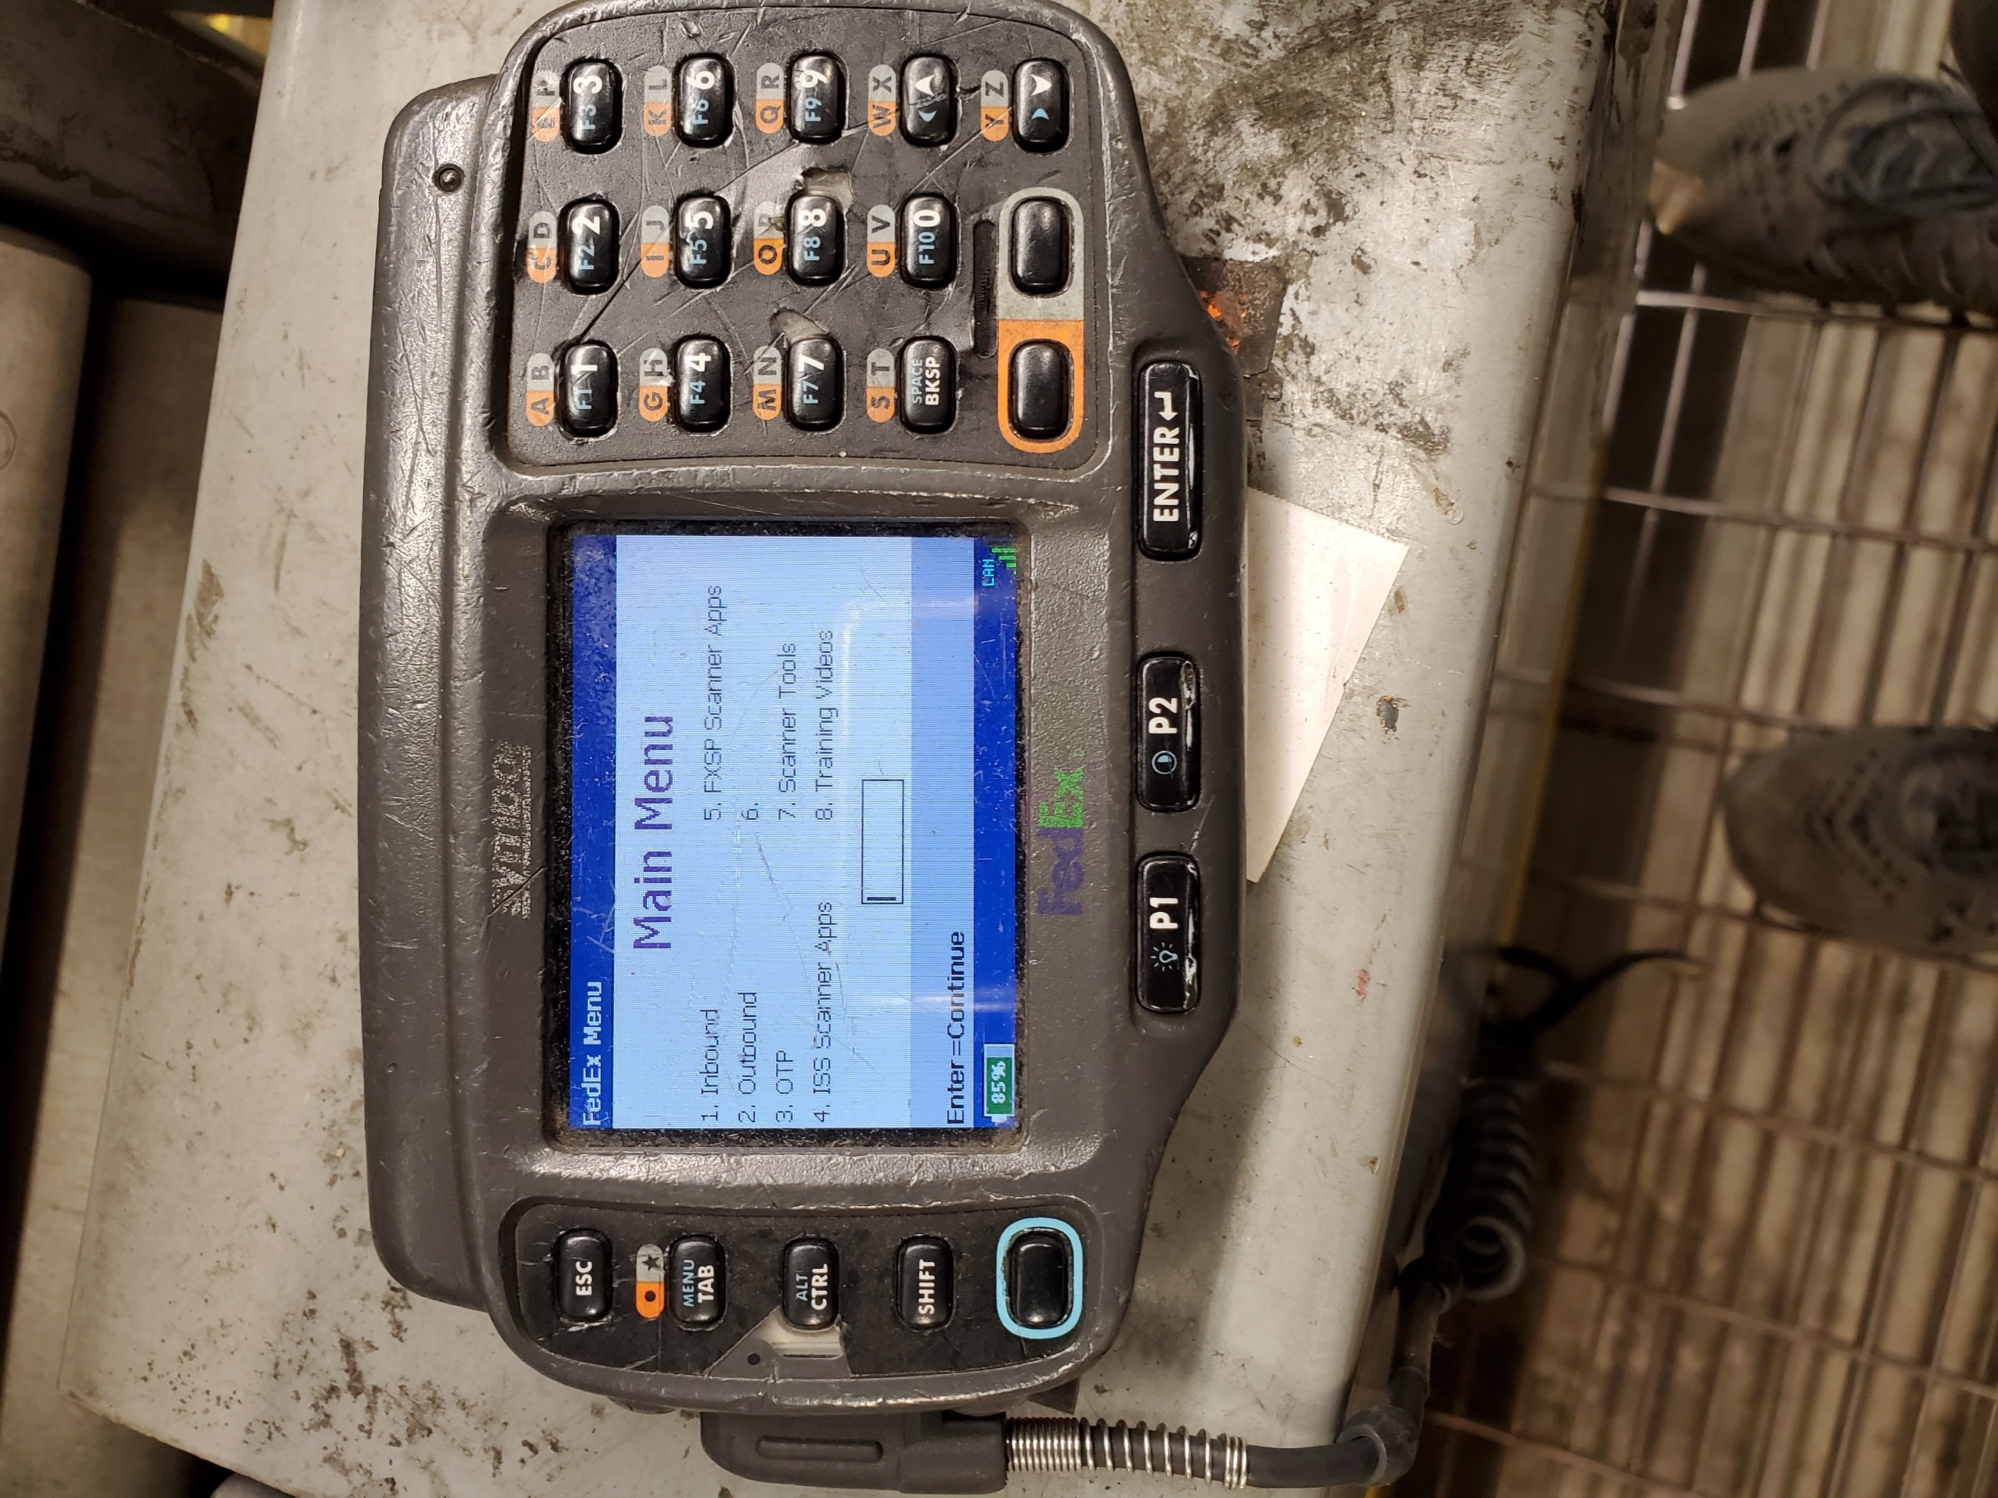

The old scanners require more work to set up, but they are the only scanners we have currently that work in unload for the purpose of inbound scanning. Old scanners have a variety of problems you may encounter, but we will go over them. Sometimes you may go through a few old scanners before you get one that properly works.

Grab an old scanner and make sure it has the trigger attached, via cable. Attach the cable to the side you wish to use - it can be on the left or right arm. For the purpose of this, it will be on the left arm (for right-handed individuals). For left-handed individuals, invert the scanner and plug the trigger cable on the other side.

With the bottom of the scanner to the ground, make sure the trigger cable is plugged in to the right-hand side. Put on your wristband with the gray piece in the middle closer to you. Slide the scanner on the wristband until you hear the click over the gray piece. Rotate the trigger so it will slide on your index finger, with the yellow button between your index finger and your thumb. The scan beam rotates independently from the button, it should face outwards. If your trigger strap is too loose, flip it over and look for a yellow tab. Using your nail, push up on the yellow tab while pulling the strap outwards (away from the yellow button). If done correctly, the strap should come off (may require force). Pull a strap from another trigger and slide it in until you hear a click.

Turn on the scanner by pressing the power button on the top left if it’s not on already. The Esc button in the top left can be used to exit any menus you may be in. You should see "Main Menu" at the top.

* Press the 1 button (Inbound), followed by enter.
* Press 2 (Preload Assist), then enter.
* Press 3 (Vision), then enter.

After this, you should eventually see a screen telling you to scan your badge. Here is where you figure out if your trigger works. Pressing the yellow button should light it up. If not, push the cable into the scanner and try again. If it still doesn’t light up, reset the scanner by taking it off and pressing 1, 9, and the power button at the same time. Set this scanner down and grab a new one. Repeat the process until you have a scanner with a trigger that works, and your badge has been scanned. If the scanner takes a while to scan your badge, it’s a bad scanner and you should grab a different one. It should scan almost instantly if you are aiming it correctly.

For unload, or inbound scanning, go to Inbound Scan (2), hit P1 or Enter to continue. Select Inbound Scan again (1), continue. Select IC Inbound scan for IC’s, or Regular for everything else (You’ll select Smalls Inbound Scan if you are working on Smalls in the Unload). Now we move on to printer setup.

Hit the button on the bottom left of your scanner (with a blue ring around it) once (toggle), and then hit the 7 button to enter pairing mode. Grab a printer and flip it so you see the buttons on the top. Make sure there is a flashing blue light (printer is on) and there is no red light (printer is jammed or out of paper). On one of the flat sides of the printer should be a small barcode. Scan this to start pairing.

If the printer connects, it will print out a sticker with your Employee # on it. You don’t need that sticker. If the printer doesn’t connect, it will display a message on your scanner. Try another printer, hit the F7 button again to enter pairing mode and scan the new printer. If the second or third printers do not connect, reset your scanner with 1, 9, and the power button and then grab a new scanner.

Take a printer belt clip if one is not already on the printer, and attach it to the printer, rotating 180 degrees to lock in place. The printer should be under your dominant hand, and the scanner should be on your non-dominant hand, for best results.

## Damaged vs. Not Damaged

### How to tape a package

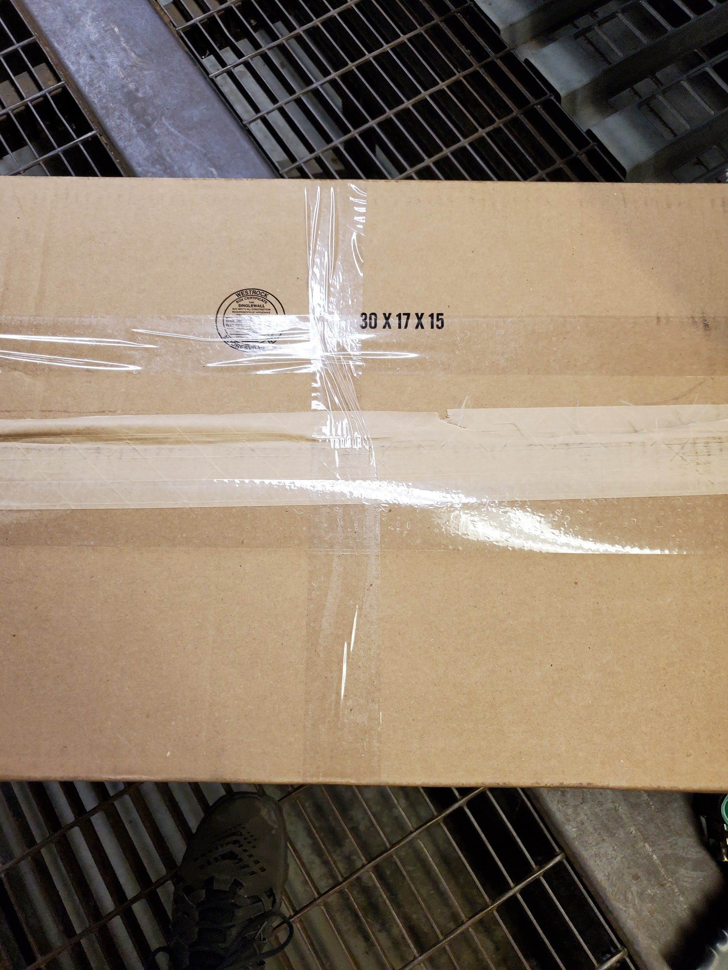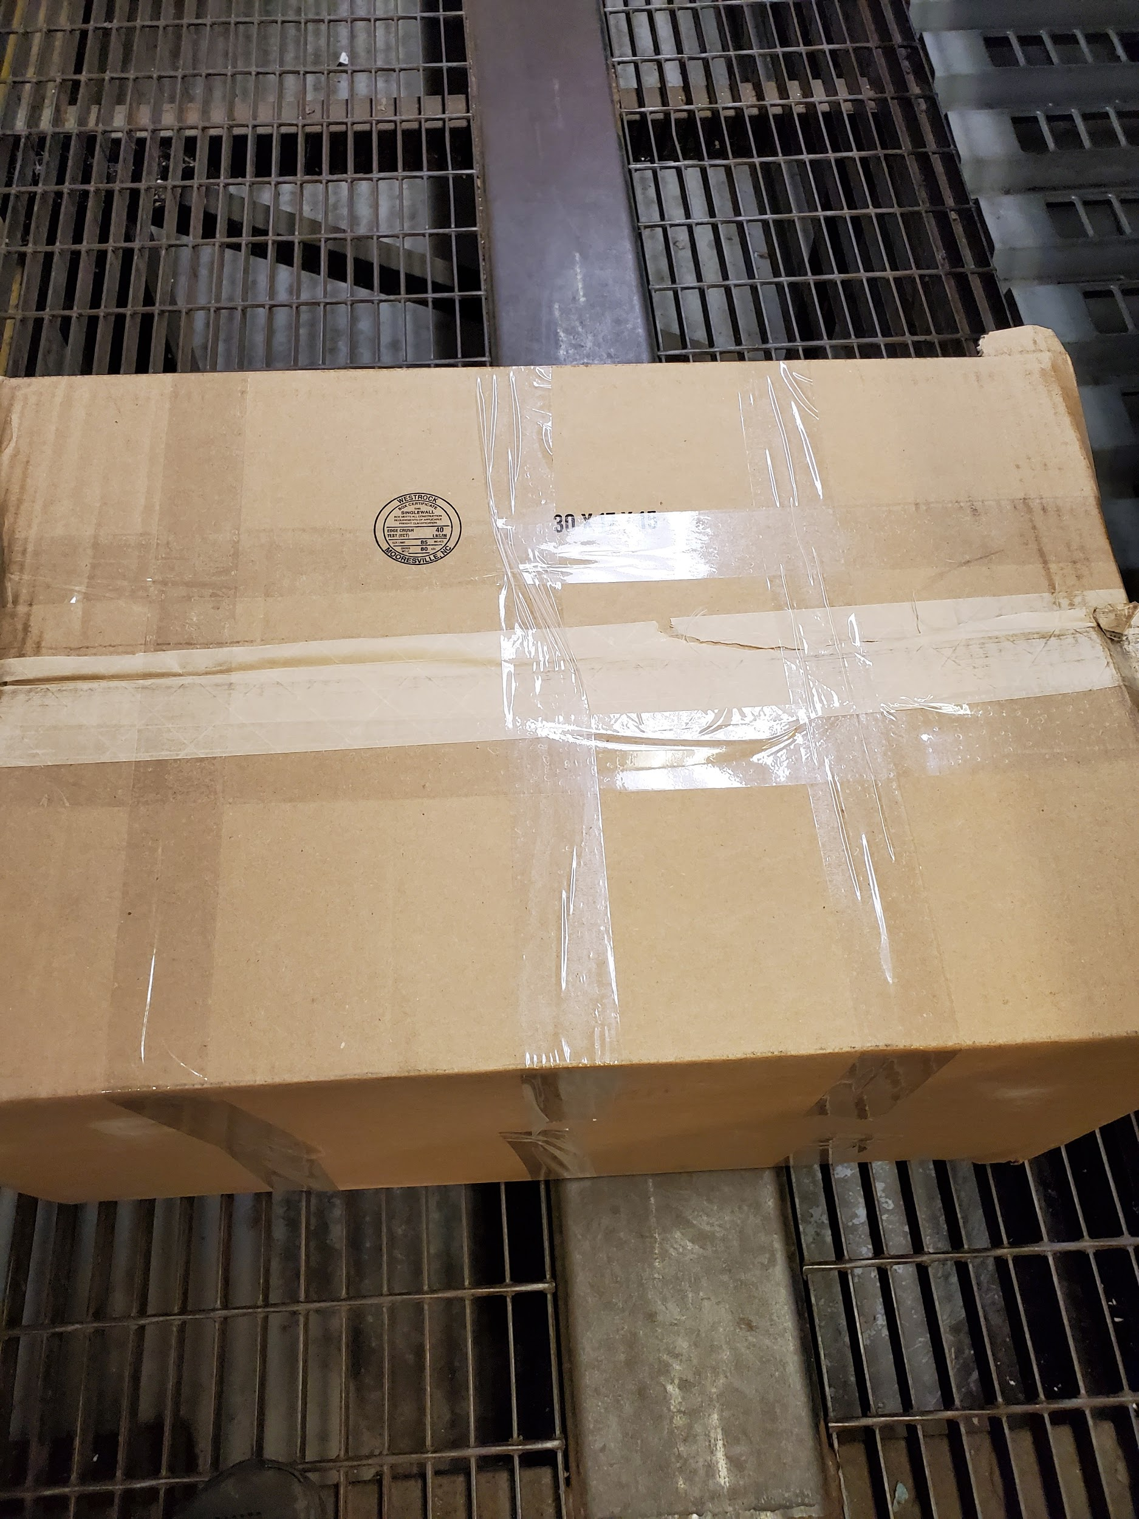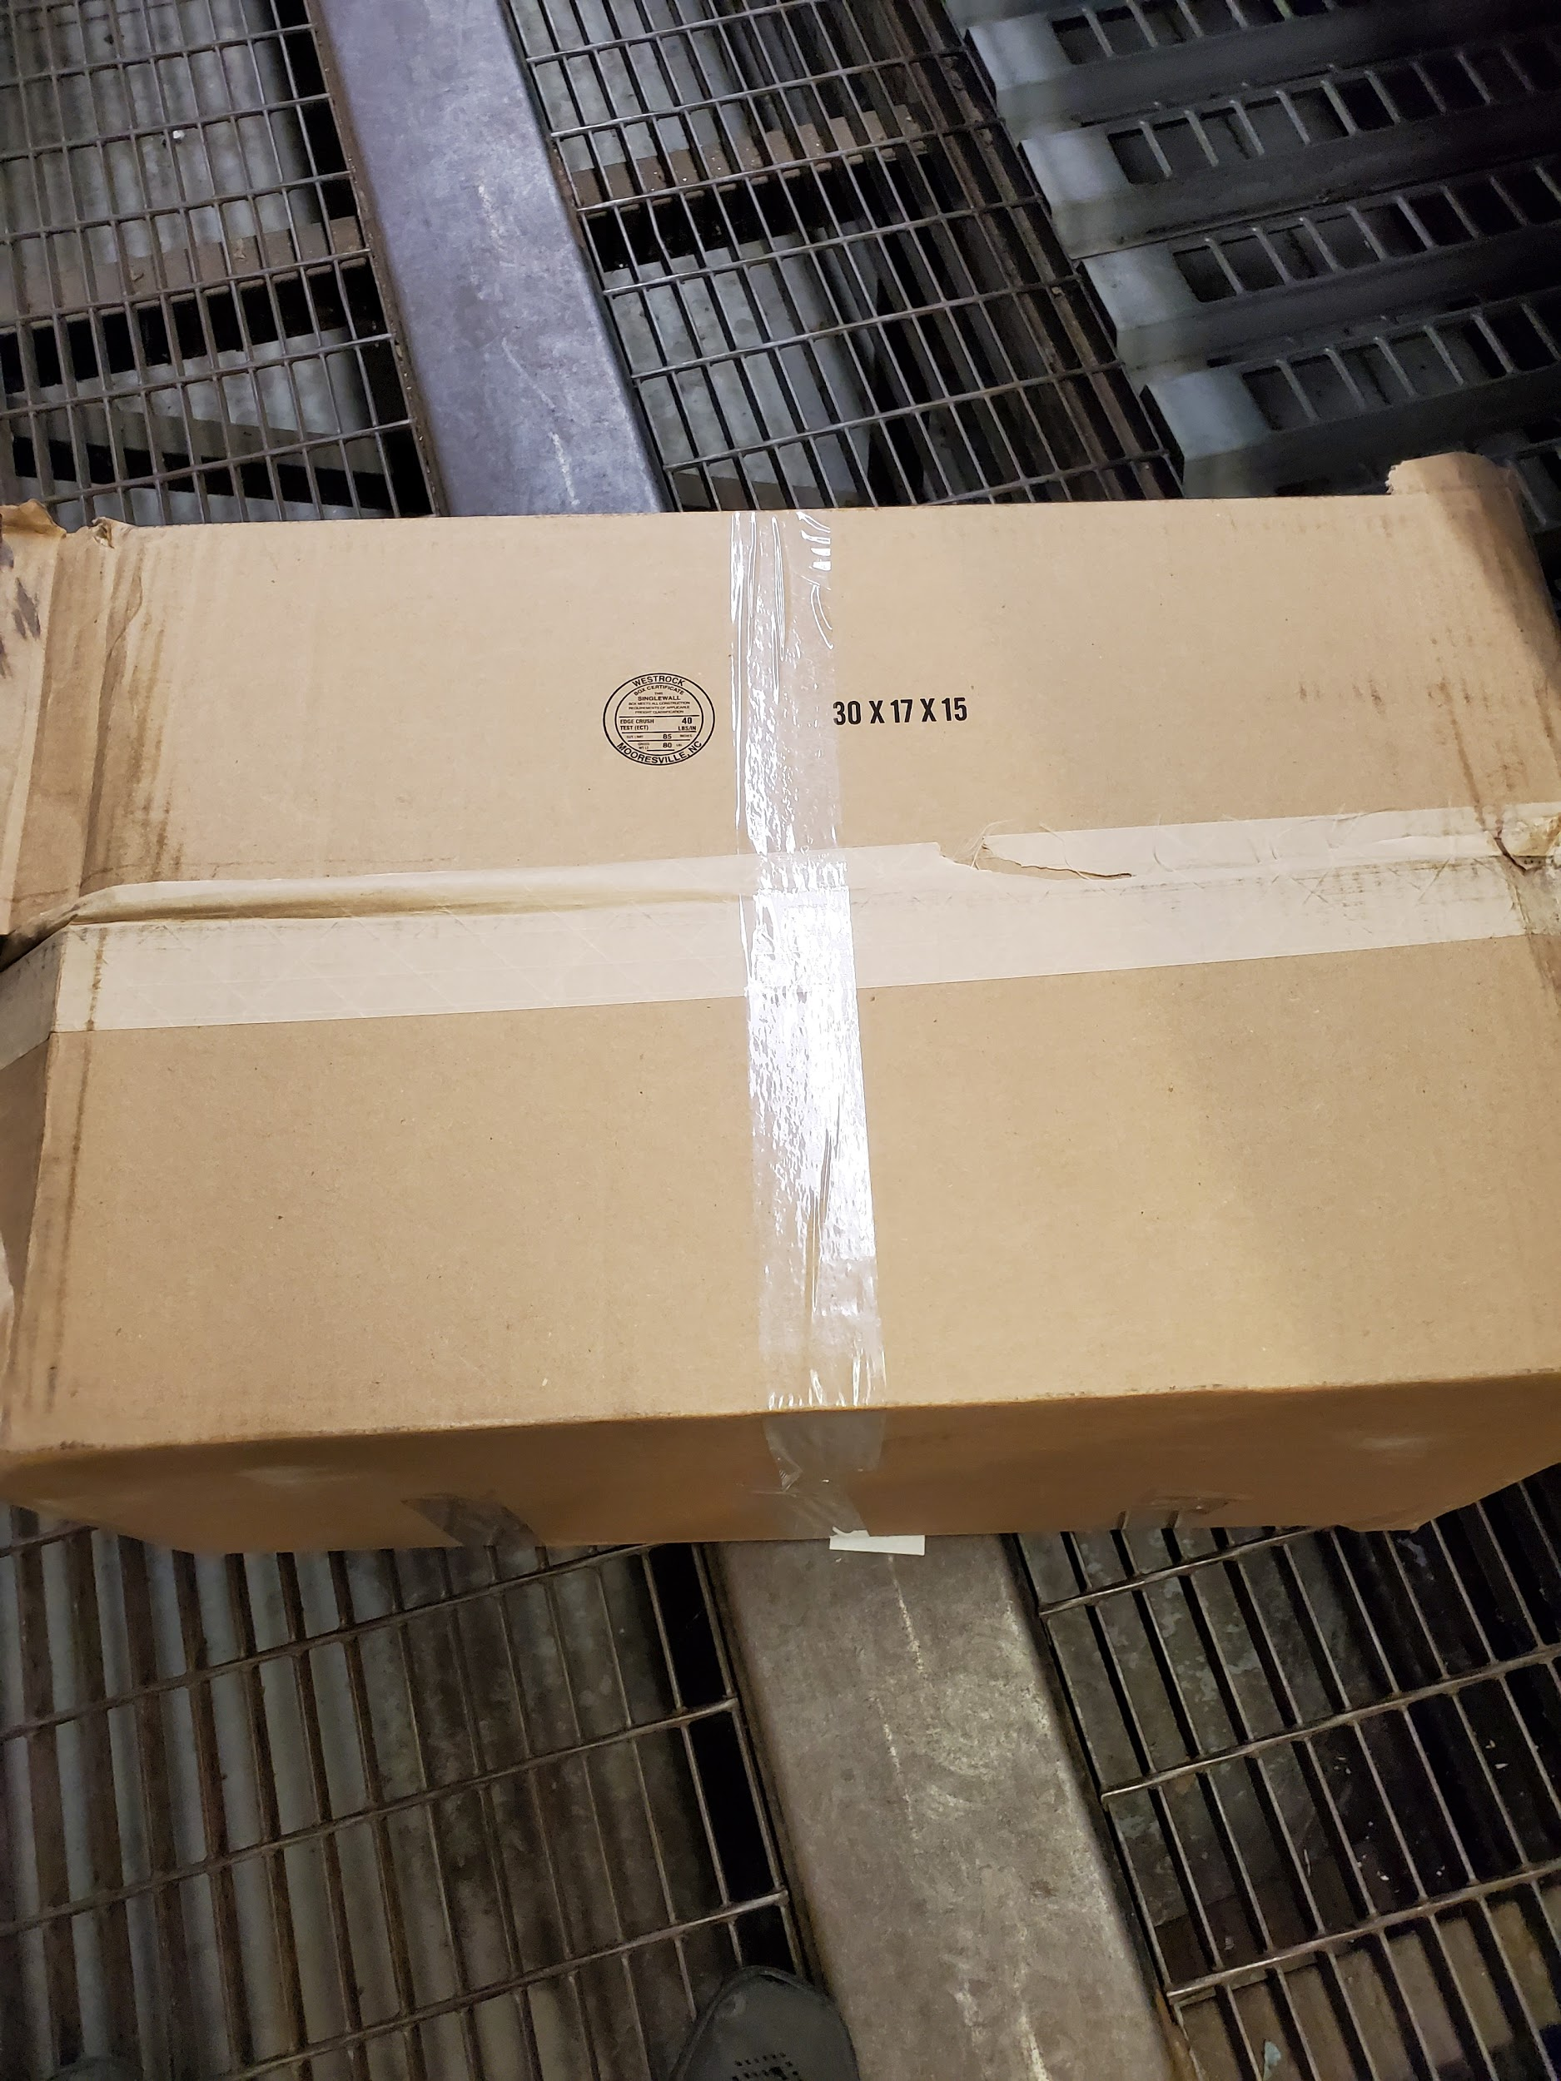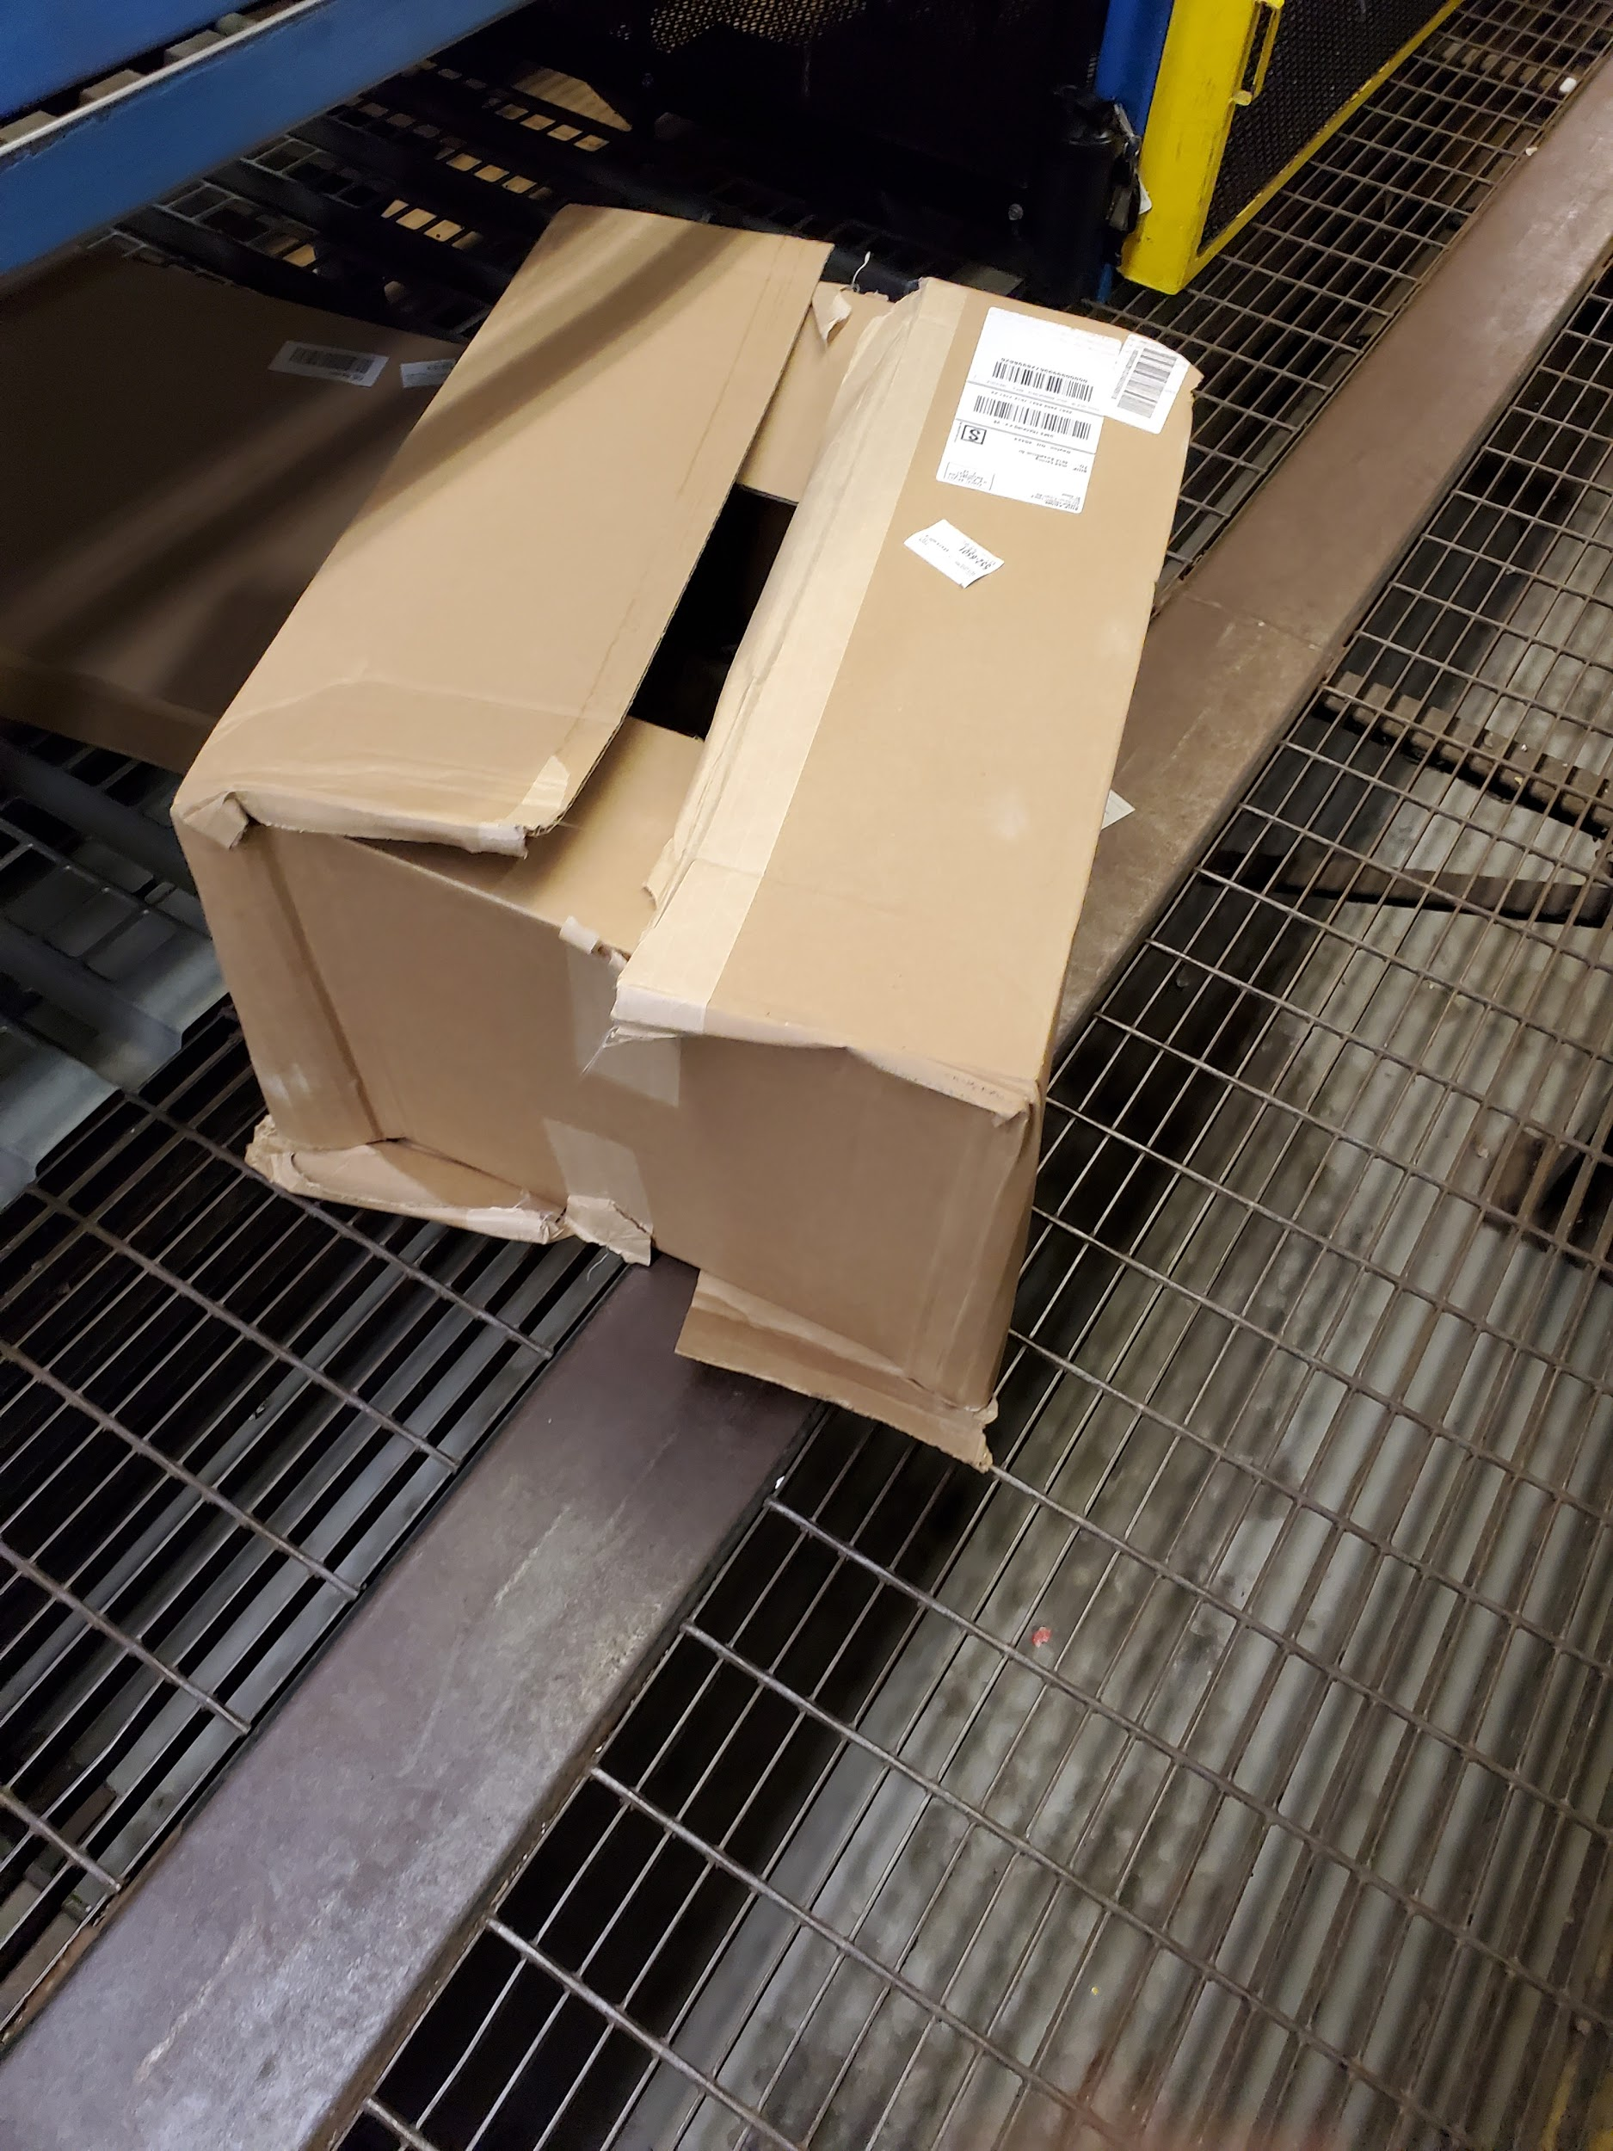

### Examples of Damaged Packages

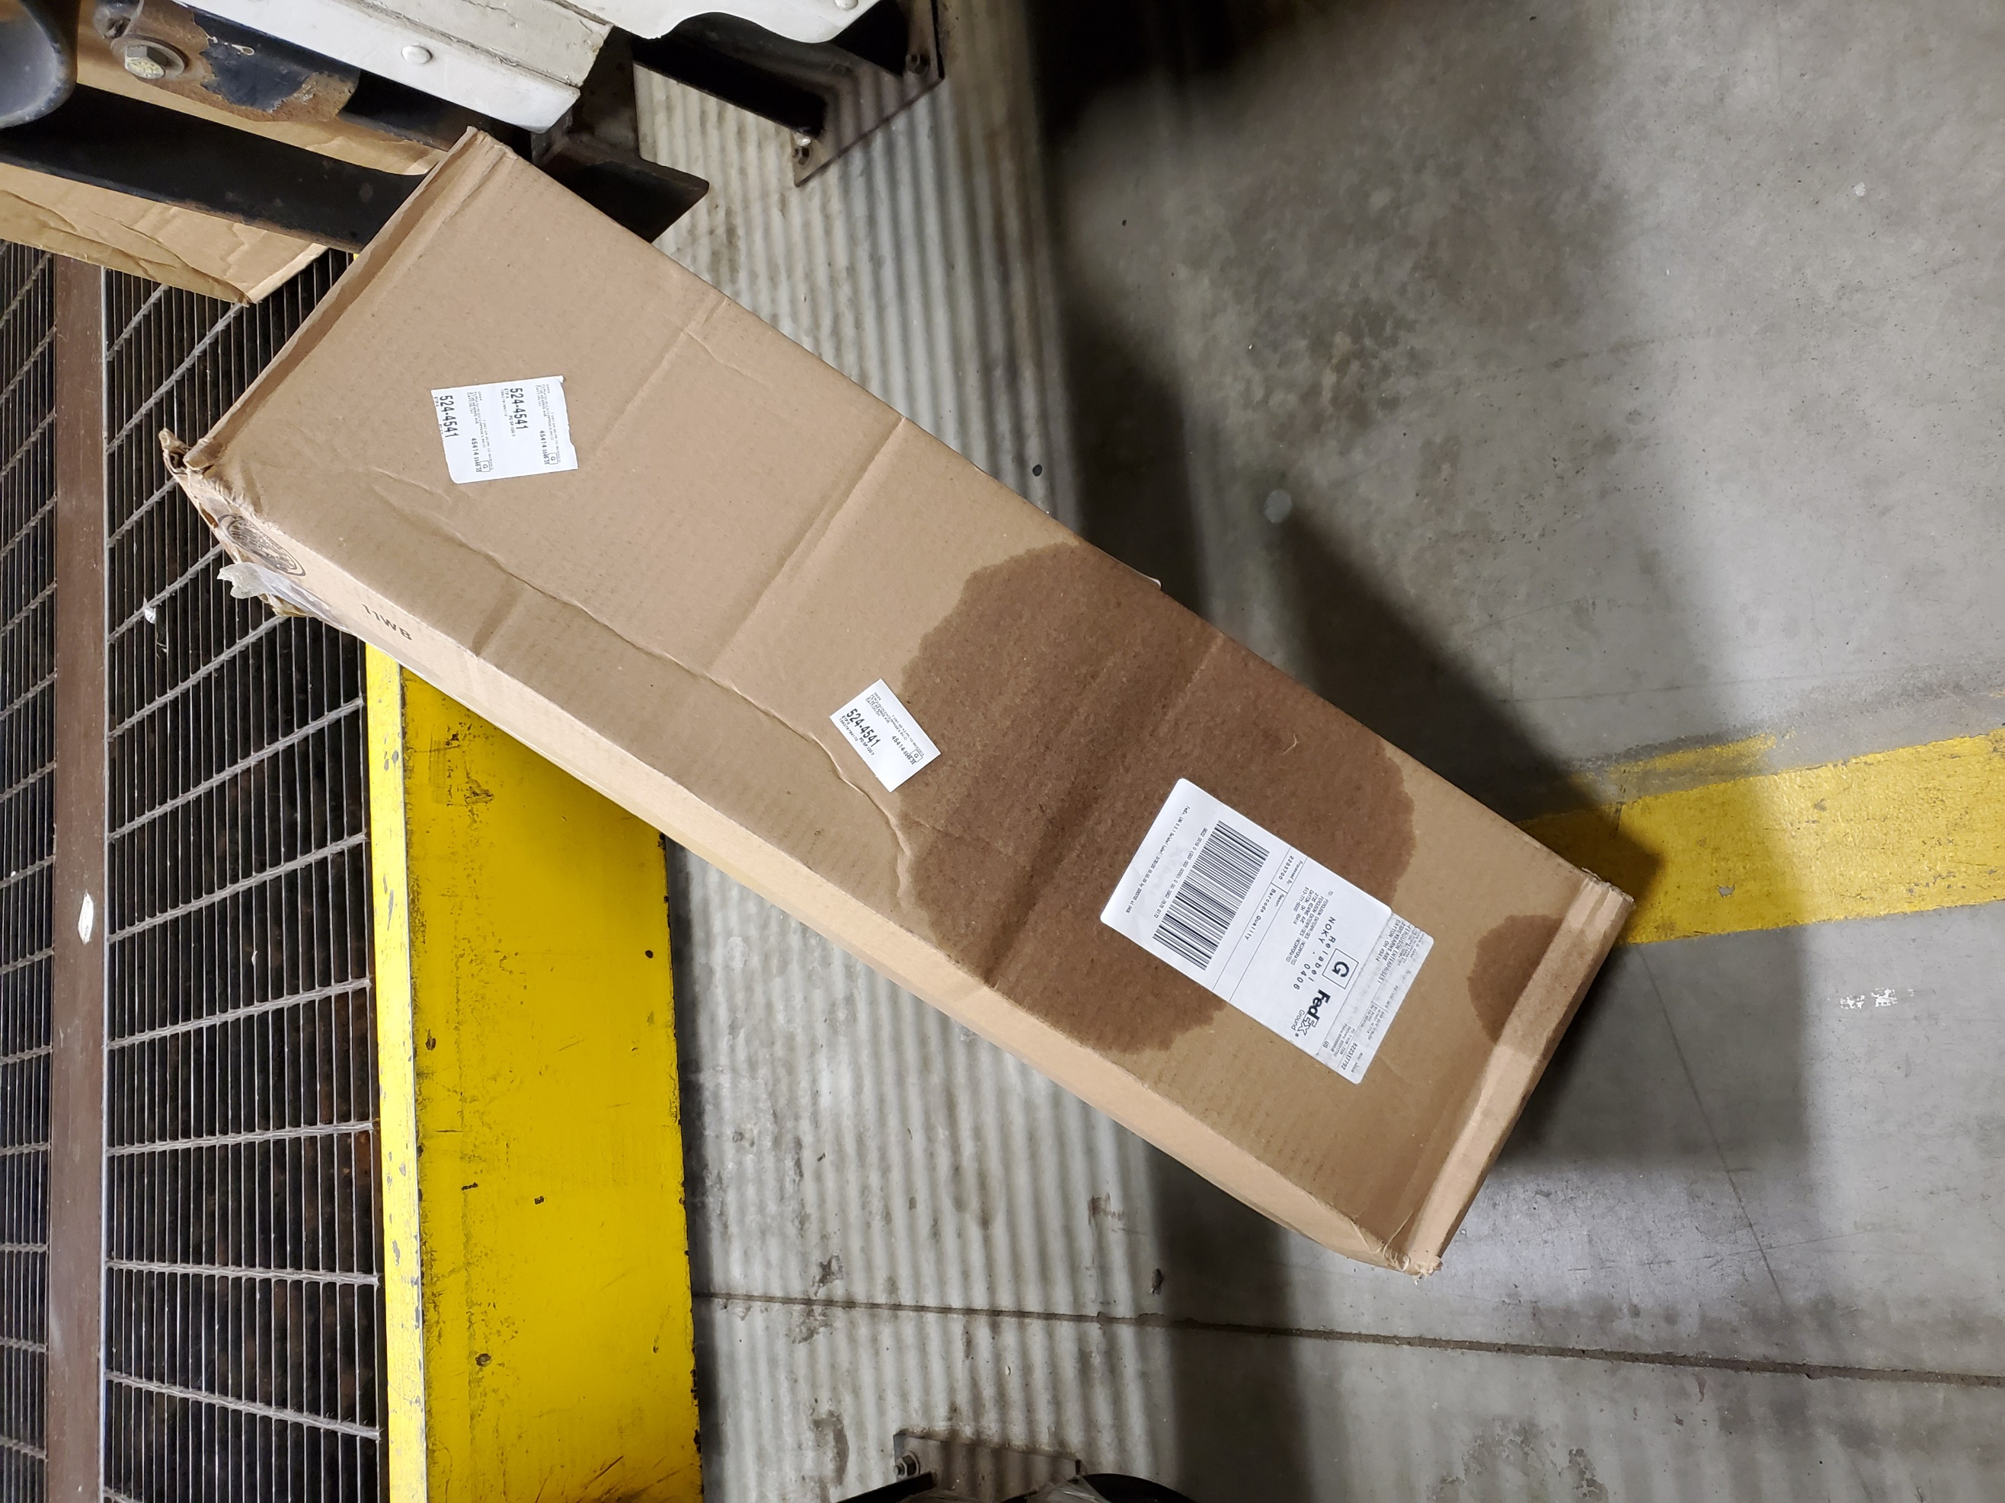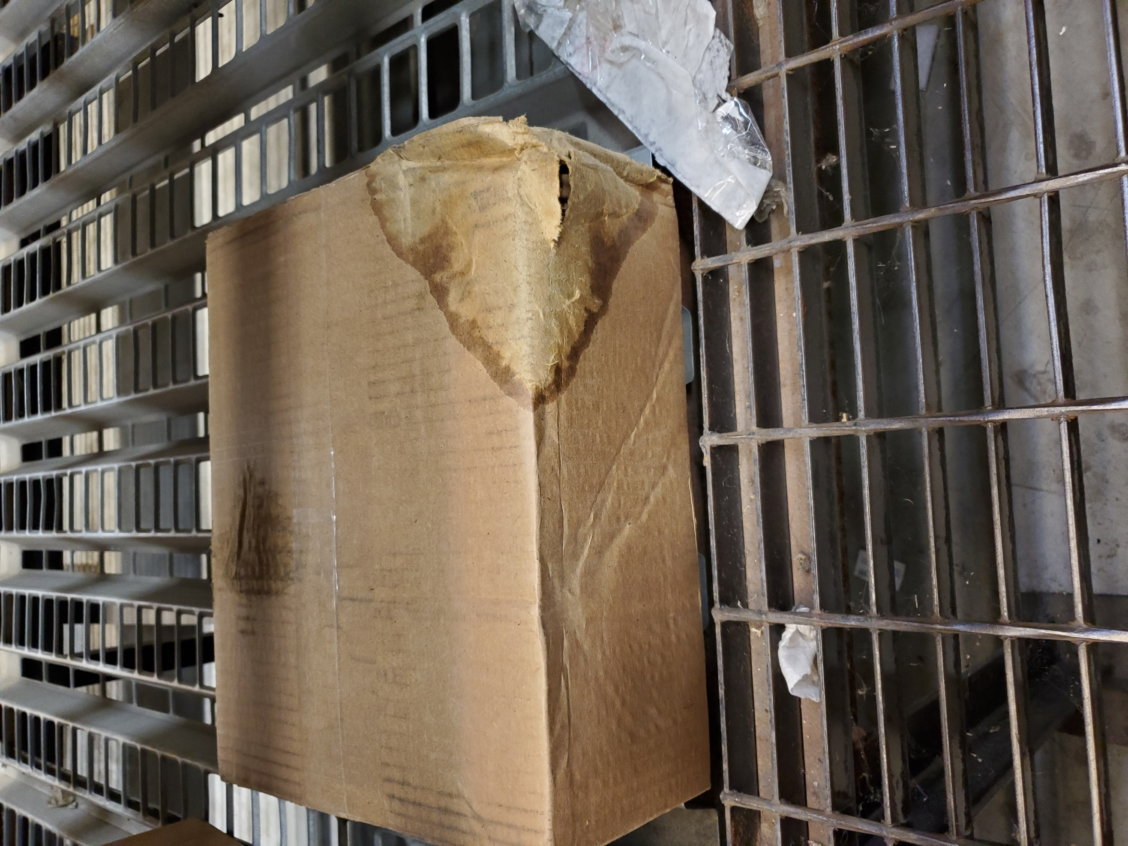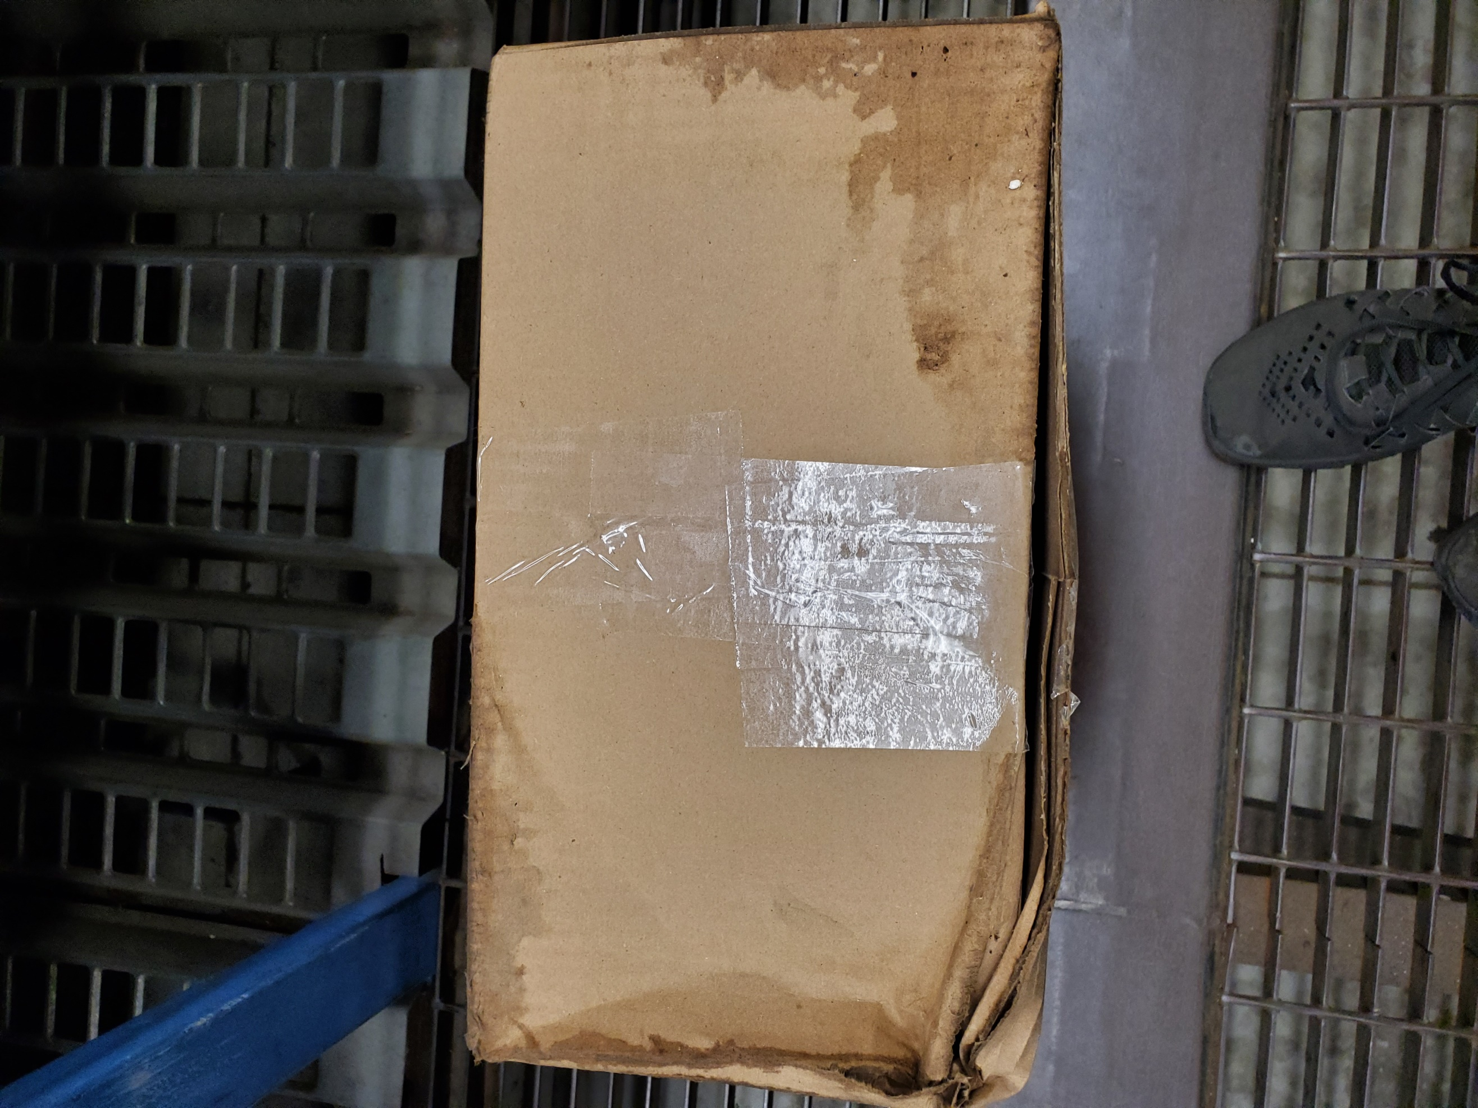

### Examples of Repacks

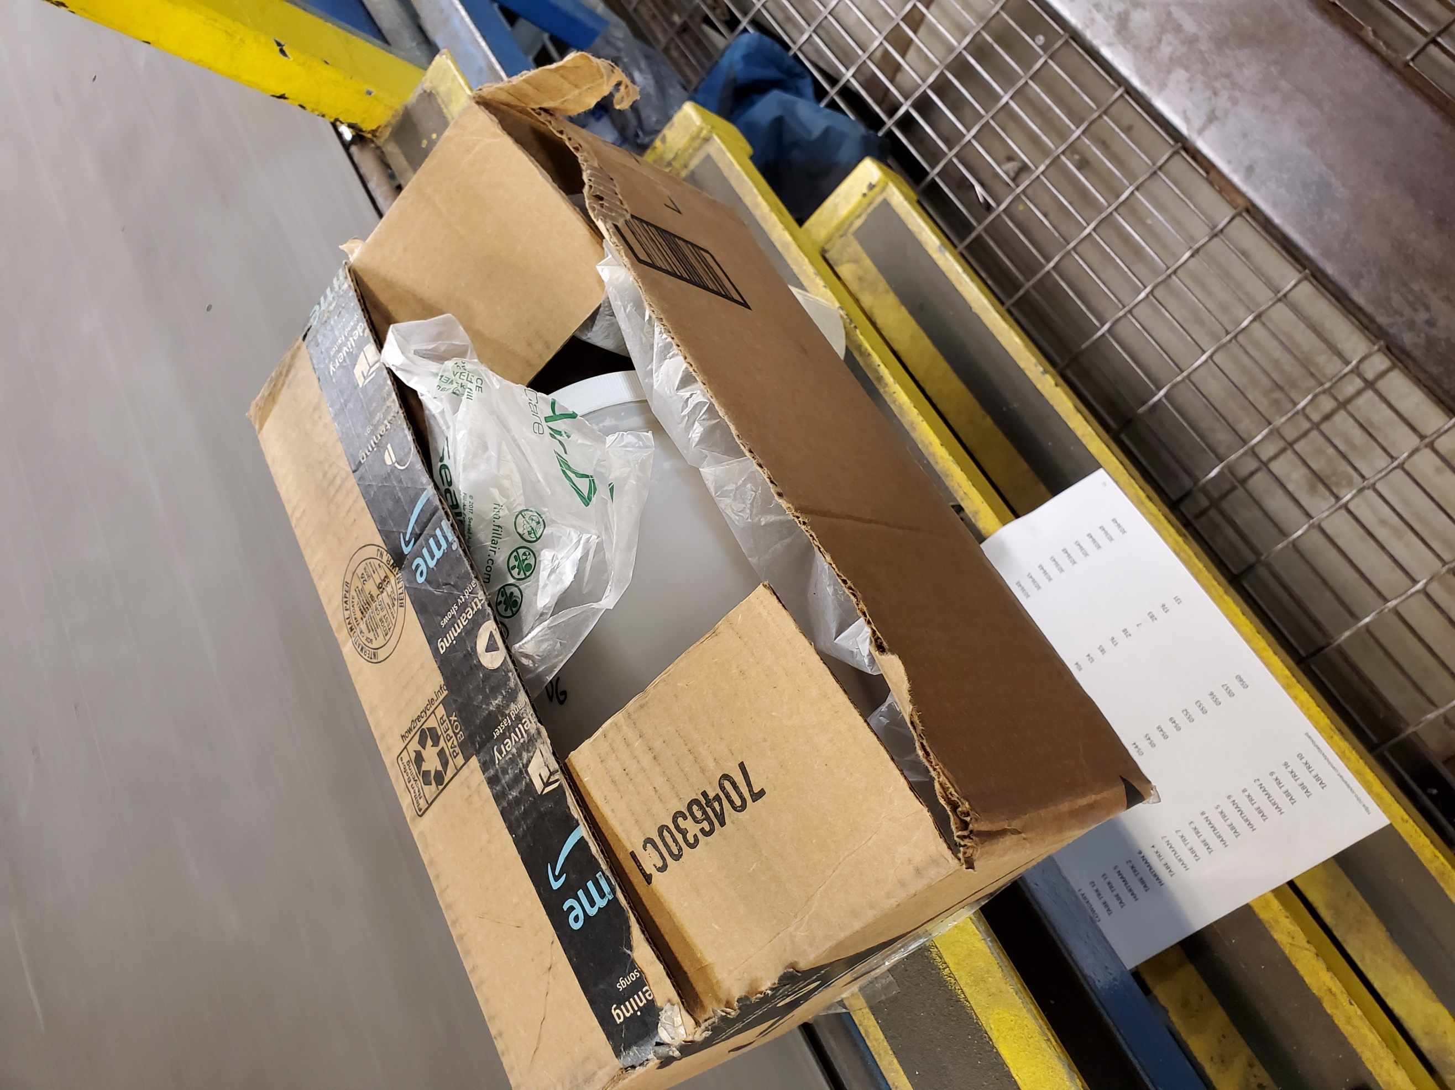

### Non-Damaged Packages

Fix with tape when you get a moment

